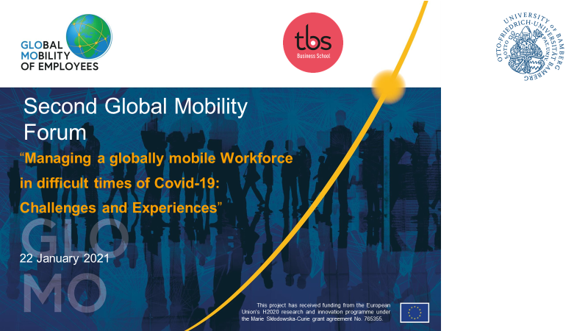c.barzantny@tbs-education.fr 25/01/2020

The second Global Mobility Forum on Friday, 22nd January 2020, 10.00–12.00 am (CEST) was again a virtual event where human resources professionals, global mobility managers, recruiters and people in leadership position were interacting with academics and international human resource scholars. Organised by Prof. Dr. Cordula Barzantny at Toulouse Business School, this 2nd edition stood under the theme “Managing a globally mobile Workforce in difficult times of Covid-19: Challenges and Experiences” and attracted an international, European, remote audience. After a lively witnessing by Benoît Pivin, Head of Global Mobility at Airbus Group. on ‘The Challenge of Covid-19 for Global Mobility @ AIRBUS’ presenting the managerial realities during this Covid-19 Pandemic, three GLOMO project ESRs gave their preliminary research findings on Global Mobility with emphasis on the pandemic. A final exchange and discussion with the audience on observations and organizational experiences across the challenging covid-19 crisis was fostering cooperation between managerial practice and academic research.

Three (out of fifteen) Early Stage Researchers (ESRs) of the GLOMO project (www.glomo.eu):
Acil Abdul Hadi, Anh Ngyuen and Giovanna Milani

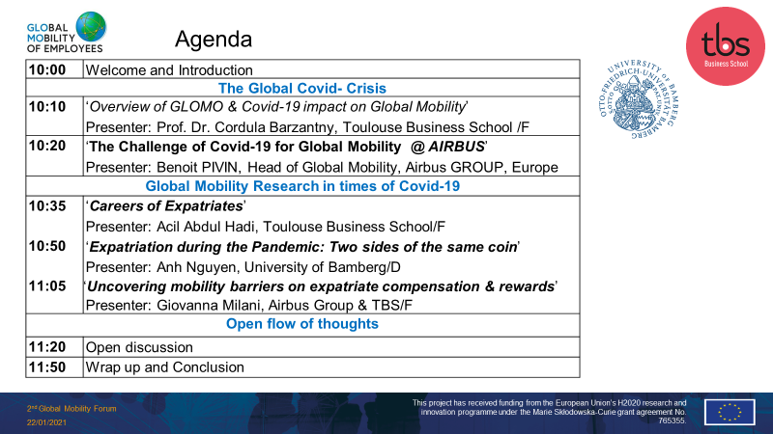

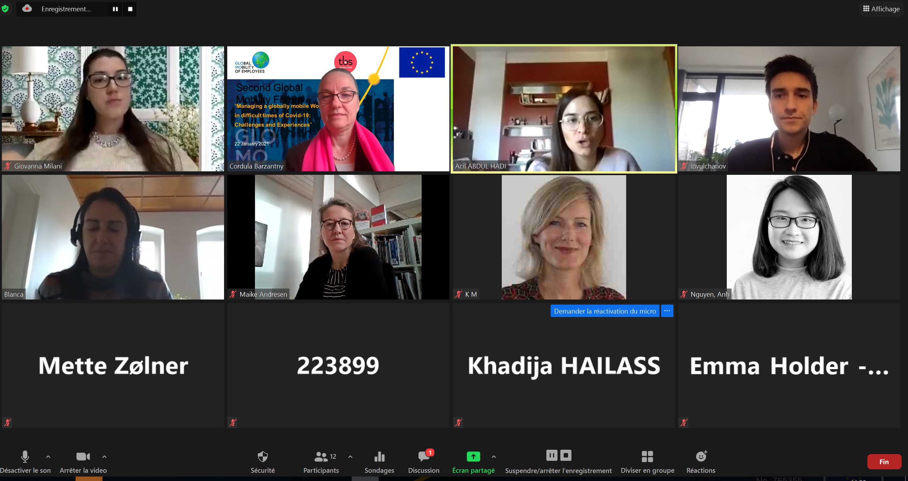

This event is part of the H2020 research project GLOMO (Global Mobility of Employees; www.glomo.eu/) funded by the European Commission. This Forum intends to focus on internationally mobile employees, corporate assigned expatriate (AE) as well as self-initiated expatriates (SIEs) considering the challenges of the Covid-19 health crisis.

https://www.tbs-education.com/news/second-global-mobility-forum/

